clientstatus.yml :

Test the connections with the localhost(self) and all of the clients

Befor fiixg the client IP iddress at hosts:

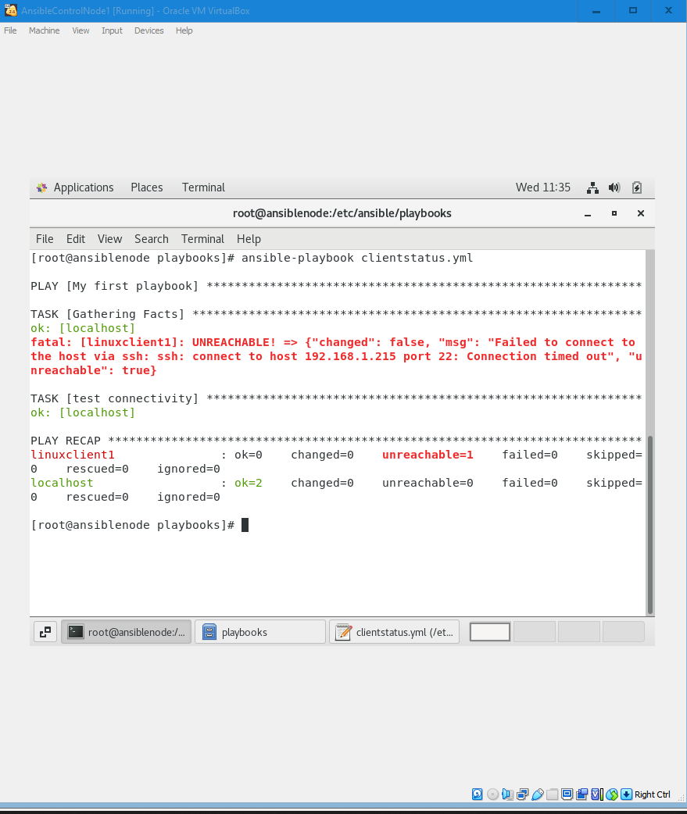

To fix the connection issue I have updated the hosts with the ipdated client IP address as shown below:

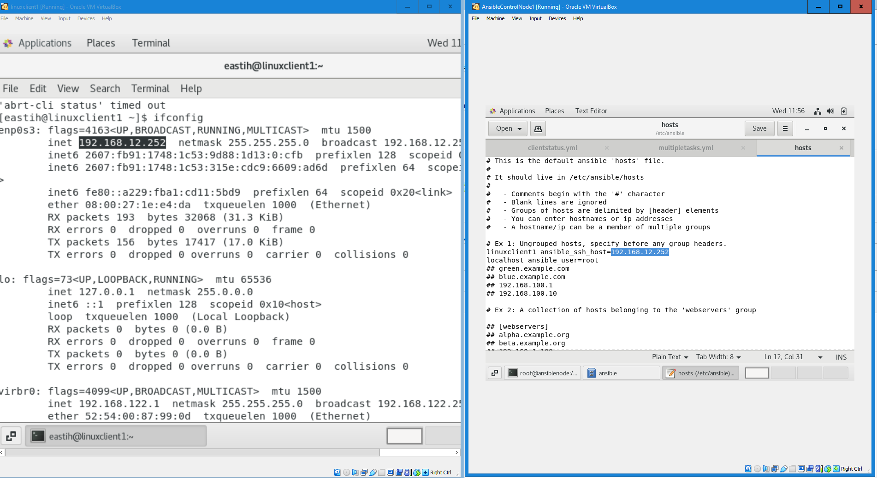

After uppdating the IP address in hosts for the client(linuxclient1):

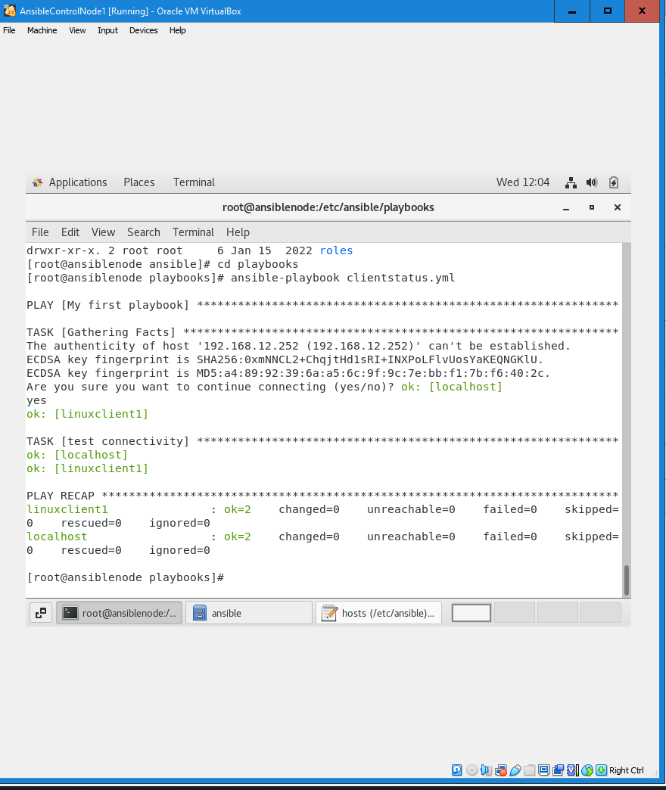

multipletasks.yml:

It check the connection(with local host “itself”) and prints the message”test Hello World”

